**Validation**

Please follow the below examples to validate that you have successfully installed the Algolia cartridge.

**Business Manager:**

All cartridge components are located in "Merchant Tools > Algolia > Algolia".

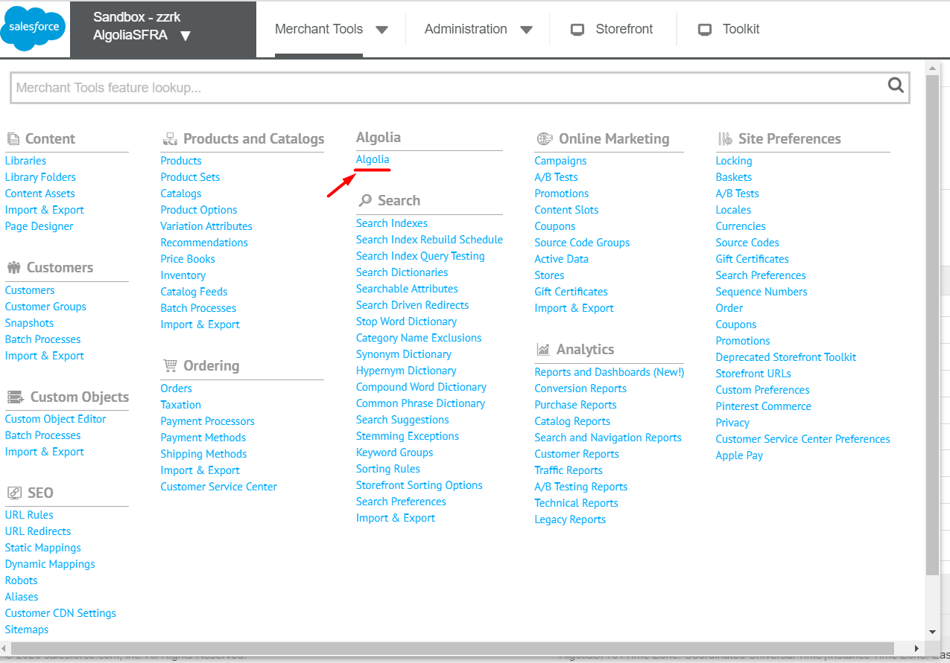

Make sure that the Algolia cartridge is turned on and filled with all preferences.

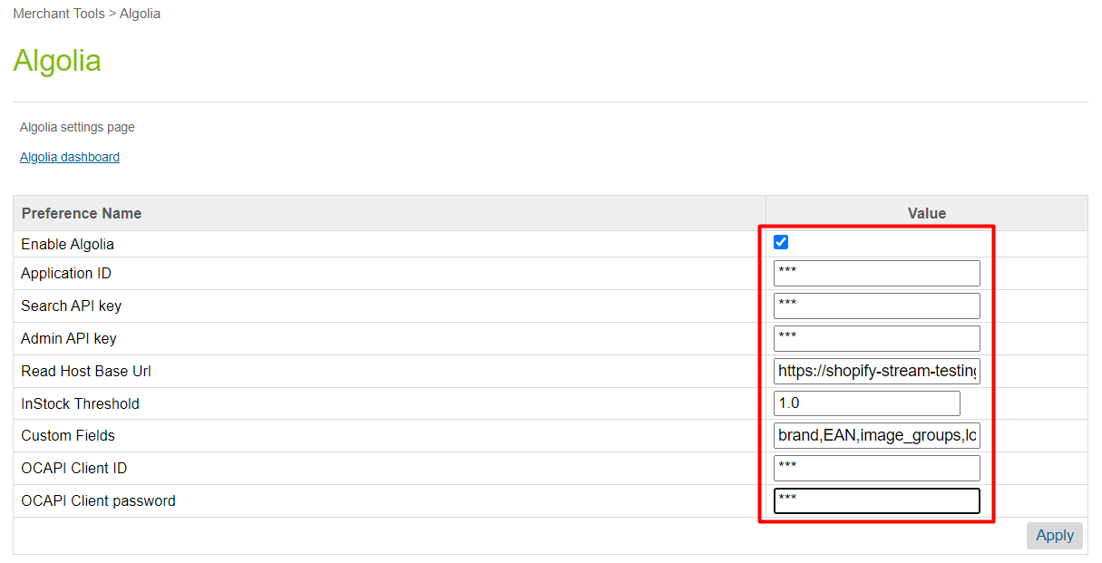

Go to section Jobs BM located in "Administration > Algolia > Jobs".

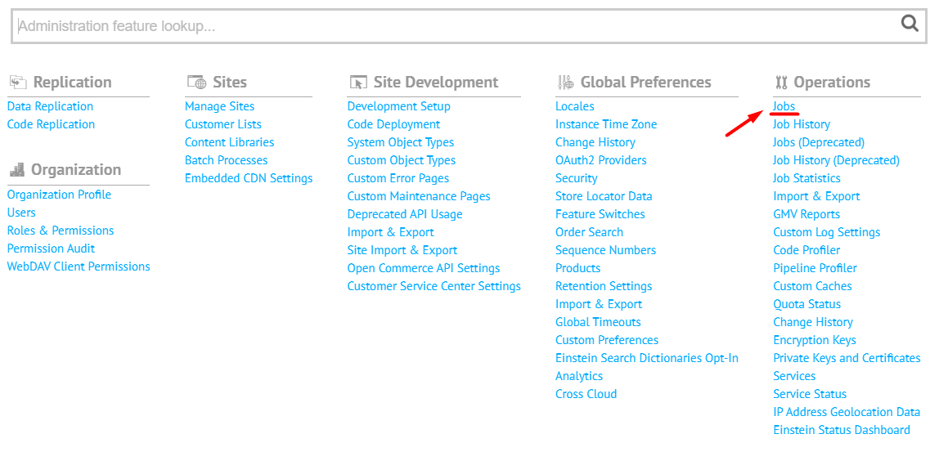

In the Jobs section, make sure you have set the correct site for scope for the AlgoliaCategoriesIndex and AlgoliaProductsIndex jobs.

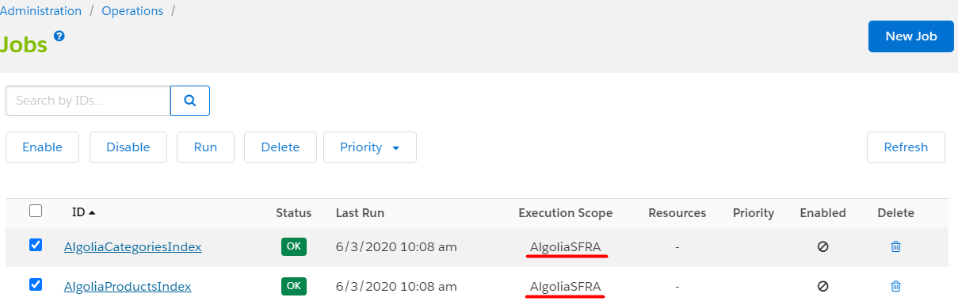

For the first run in the Job Steps section for the AlgoliaProductsIndex for calculateProductsDelta step set parameter “clearAndRebuild” with value “true”. This will force the job to delete all the snapshots, rebuild them, and send new data to Algolia.

After a successful first run of the job, the parameter “clearAndRebuild” has to be set to the value “false” again.

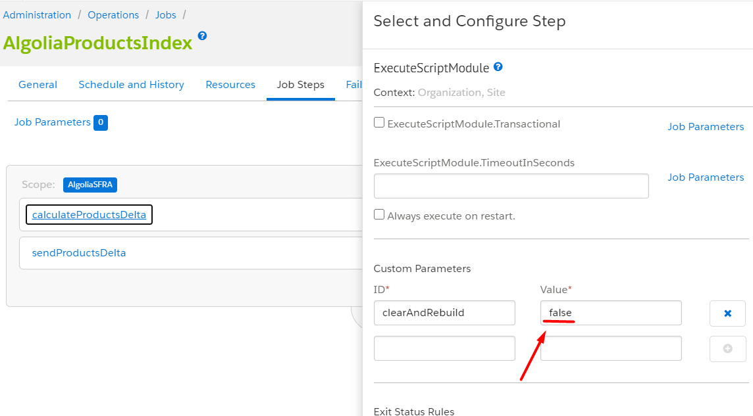

The same for the first run in the Job Steps section for the AlgoliaCategoriesIndex for calculateСategoriesDelta step set parameter “clearAndRebuild” with value “true”. - this will force the job to delete all the snapshots, rebuild them, and send new data to Algolia.

After a successful first run of the job, the parameter “clearAndRebuild” has to be set to the value “false” again.

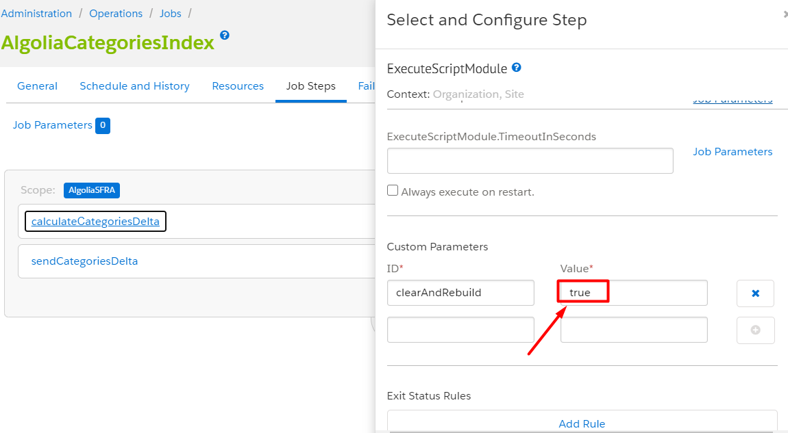

Return to the Job Steps section, select the AlgoliaProductsIndex and AlgoliaCategoriesIndex and run jobs.

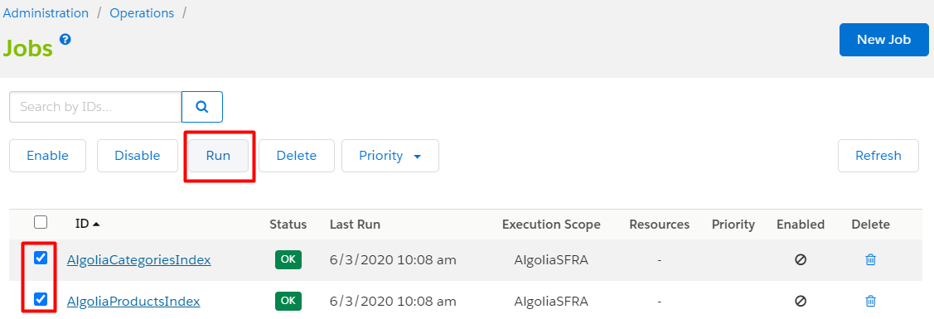

Wait until the jobs are completed and make sure that the jobs are completed with status OK (without errors).

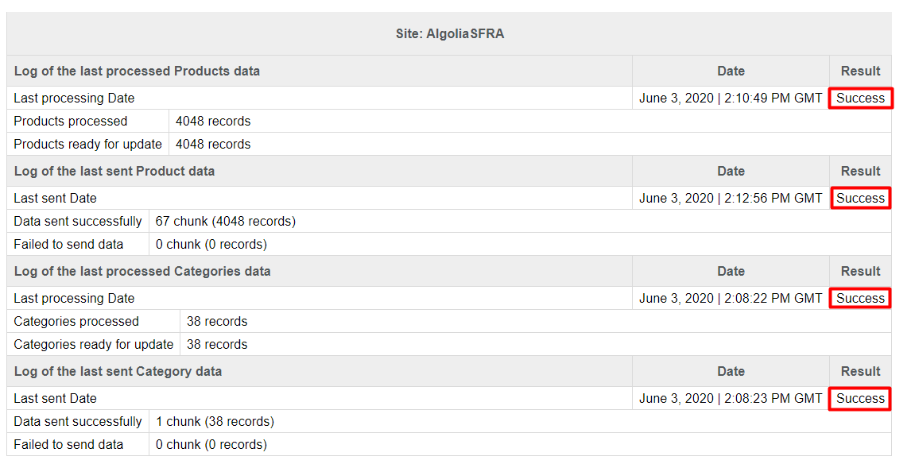

Go to the Algolia control panel and make sure the indexes are created.

Tre products index name should be in the next format: {SandboxID}__{SiteID}__products__{LocaleID}.

The categories index name should be in the next format: {SandboxID}__{SiteID}__categories__{LocaleID}.

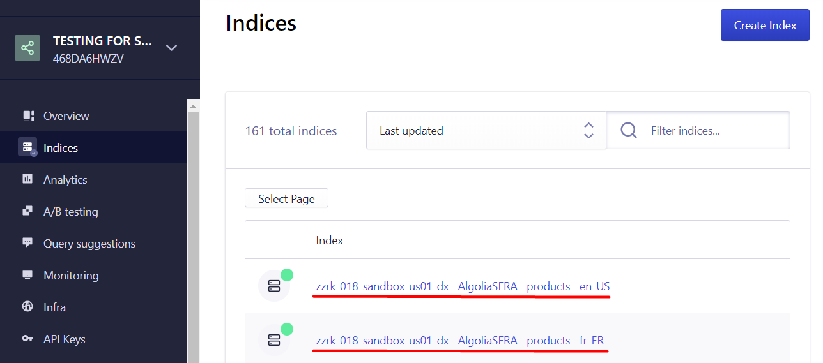

Go to the products index and “Configuration > Facets > + Add an Attribute”. Add the attributes __primary_category.0, __primary_category.1 and __primary_category.2.

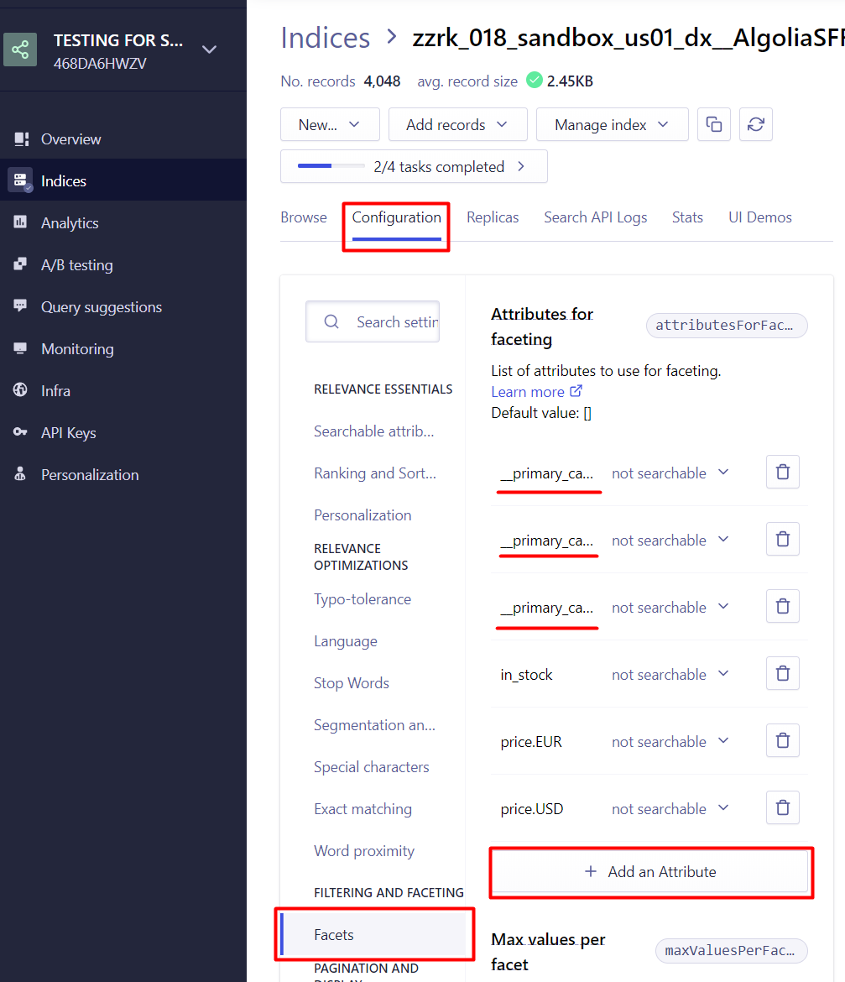

Go to the storefront and start typing the name of one of the products in the search field - ‘su’ for example. Under the search field you can see a list of products and categories which have ‘su’ in product name.

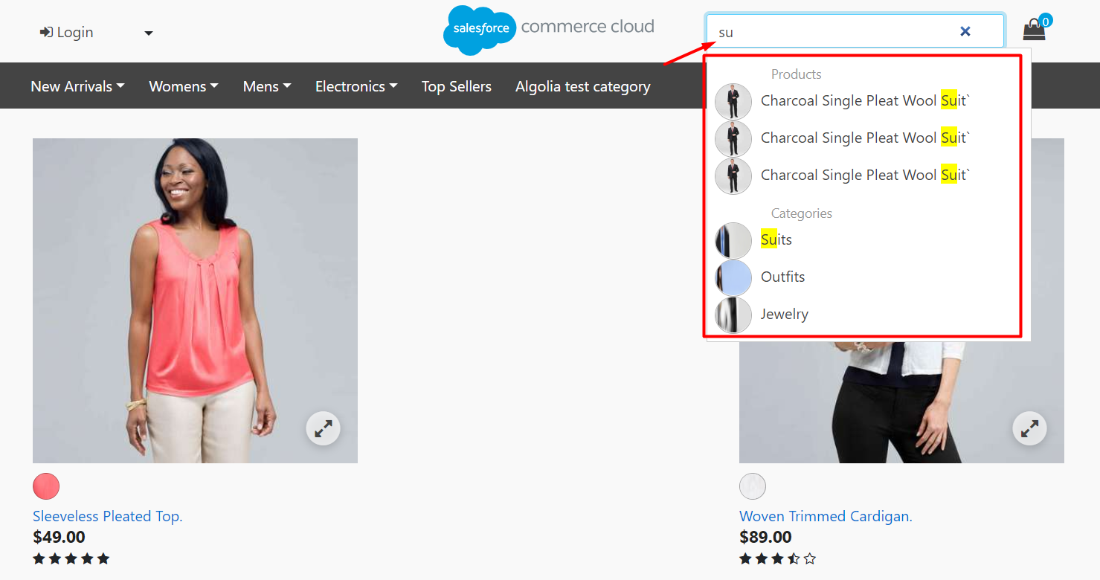

Go to one of categories – ‘Womens > Clothing > Outfits” for example. You can see the tree of categories, the current categories should be marked and you should see the list of the product of the selected category.

